Traffic Light Classification using VGG16 Transfer Learning

1. Introduction
Accurate traffic-light colour recognition is important for autonomous vehicles because wrong red or green predictions can lead to accidents. This project developed a binary image classification system to classify two traffic-light states: Green and Red. I used an expanded dataset containing from Kaggle that had 2,482 images, with 1,296 Green images and 1,186 Red images. This was an improvement over the original 200-image dataset. It gave the model more examples of traffic-light appearance, lighting variation, background variation and image quality differences.
Transfer learning with VGG16 was used because its pretrained convolutional layers provide visual features while only a task-specific classifier head needed to be trained. Three variations of the model were compared: a frozen VGG16 baseline with data augmentation, an independent improvement using stronger regularisation, and an independent improvement using classification threshold tuning.

2. Dataset Preparation
The final dataset contained 2,482 images organised into Green and Red classes. Images were loaded using OpenCV. Since OpenCV reads images in BGR order, every image was converted to RGB before being passed into the model pipeline. All images were resized to 224 x 224 pixels, matching the standard VGG16 input size. Pixel values were kept in the 0-255 range because the model included the VGG16 preprocess_input function as seen in the model design.
Labels were encoded using LabelEncoder and converted to one-hot format with to_categorical. This allowed the classifier to use a two-neuron softmax output layer with categorical cross-entropy loss. A stratified split was used to keep the Green and Red class distributions approximately balanced in the training, validation and testing subsets. The split used 70% of images for training, 15% for validation and 15% for testing.
Table 1
Stratified dataset split used for training, validation and testing.
Subset | Total images | Green | Red | Purpose
Training | 1,737 | 907 | 830 | Model fitting
Validation | 372 | 194 | 178 | Early stopping and threshold selection
Testing | 373 | 195 | 178 | Evaluation

Data augmentation was applied inside the model so that transformations occurred only during training. The augmentation pipeline included horizontal flipping, small rotation, zooming and contrast adjustment. These operations made the model see varied versions of the same training images and reduced the risk of simply memorising the dataset.

3. Model Design
The baseline model used VGG16 with include_top=False, removing the original ImageNet classification layers. The VGG16 convolutional base was frozen, meaning its pretrained ImageNet weights were not updated during training. A new classification head was added consisting of GlobalAveragePooling2D, Dense (128, ReLU), Dropout (0.25), and a final Dense (2, Softmax) output layer. The two output neurons produced probabilities for the Green and Red classes.
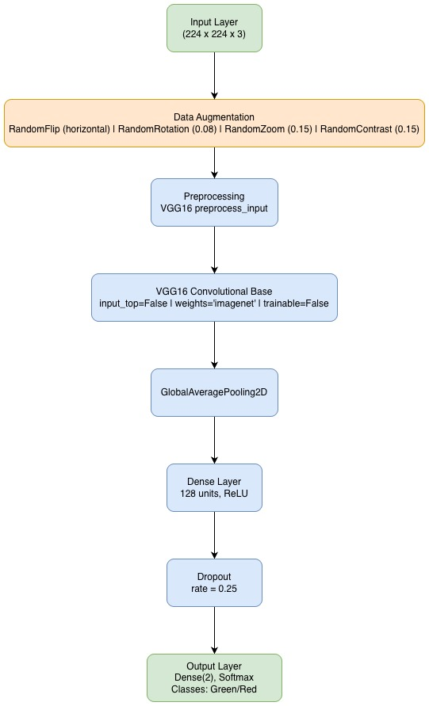
Figure 3.1: Model design for the frozen VGG16 baseline with data augmentation.
The model was trained using the Adam optimiser with a learning rate of 1e-4. Model 1 was the baseline model. Model 2 tested stronger regularisation through L2 regularisation and a higher dropout rate. Model 3 tested threshold tuning by adjusting the Red-class probability threshold using validation-set results.
Table 2
Summary of the baseline VGG16 model architecture.
Layer | Configuration | Purpose
Input | 224 x 224 x 3 | Receives RGB image
Data augmentation | Flip, rotation, zoom, contrast | Increases training variation
Preprocessing | VGG16 preprocess_input | Matches ImageNet preprocessing
VGG16 base | Frozen, ImageNet weights | Feature extraction
GlobalAveragePooling2D | 512 output features | Reduces feature maps
Dense + Dropout | 128 ReLU units, dropout 0.25 | Classification head
Output | Dense(2), Softmax | Green / Red probabilities

4. Model 1: Frozen VGG16 with Data Augmentation
Model 1 achieved a test accuracy of 97.86% and a test loss of 0.0486. The classification report showed high performance for both classes. For the Green class, precision was 0.99, recall was 0.96 and F1-score was 0.98. For the Red class, precision was 0.96, recall was 0.99 and F1-score was 0.98.
The confusion matrix showed that 188 out of 195 Green images were correctly classified, while 7 Green images were predicted as Red. For the Red class, 177 out of 178 images were correctly classified, with only 1 Red image predicted as Green. The baseline model made 8 total errors on the 373-image test set.
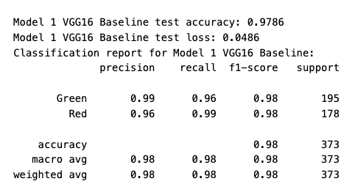
Figure 4.1: Classification report summary.

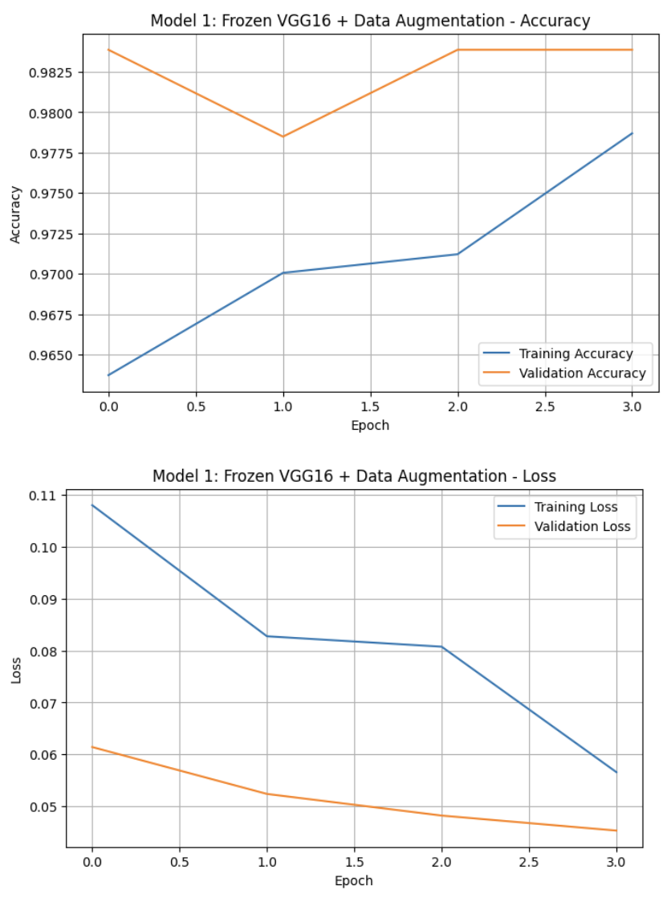
Figure 4.2: Model 1 training and validation accuracy/loss curves.
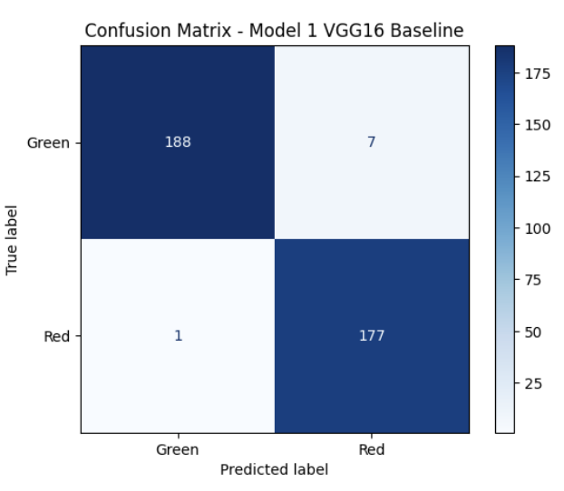
Figure 4.3: Confusion matrix for Model 1.

5. Improvement Method 1: Stronger Regularisation
The first improvement method added L2 regularisation to the dense layer and increased dropout to 0.50 while keeping the VGG16 convolutional base frozen. The aim was to reduce overfitting and encourage the classifier head to learn a more general decision boundary.
Model 2 achieved the best overall result, with a test accuracy of 98.93% and a test loss of 0.2232. Green precision was 0.99, recall was 0.98 and F1-score was 0.99. Red precision was 0.98, recall was 0.99 and F1-score was 0.99. Compared with Model 1, the total number of errors decreased from 8 to 4. The confusion matrix showed 192 correctly classified Green images and 177 correctly classified Red images. Only 3 Green images were predicted as Red and only 1 Red image was predicted as Green.
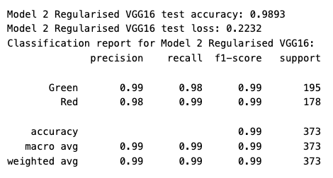
Figure 5.1: Classification report summary.
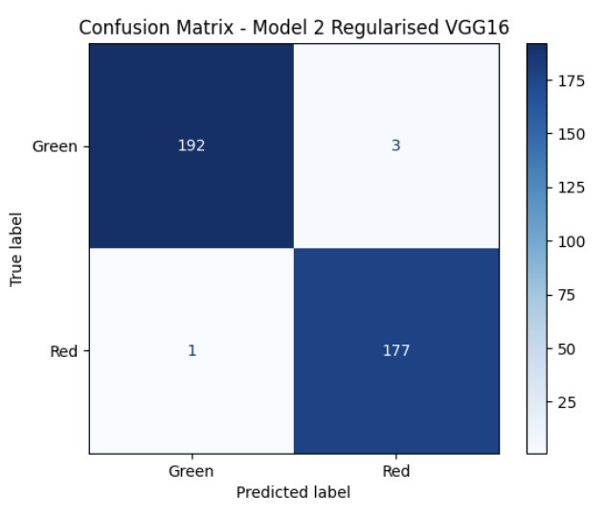
Figure 5.2: Confusion matrix for Model 2.

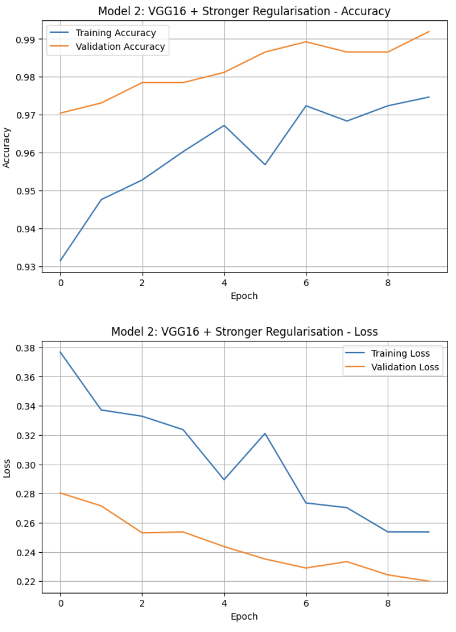
Figure 5.3: Model 2 training and validation accuracy/loss curves.
This improvement was successful because it improved the baseline test accuracy from 97.86% to 98.93%. It also reduced total errors from 8 to 4, showing that regularisation improved generalisation rather than merely increasing training performance. Model 2 was selected as the best final classifier.

6. Improvement Method 2: Classification Threshold Tuning
The second improvement method was classification threshold tuning which changed the final decision rule used to convert the baseline model probabilities into class labels. Different Red-class probability thresholds were tested using the validation set, and the threshold with the best validation macro F1-score was selected. This method was applied to Model 1 probabilities.
The best Red threshold was 0.65. At this threshold, validation accuracy was 0.9866 and validation macro F1-score was 0.9865. On the test set, threshold tuning achieved 98.66% accuracy, macro precision of 0.9863, macro recall of 0.9869 and macro F1-score of 0.9866. The confusion matrix showed 191 correctly classified Green images and 177 correctly classified Red images. There were 4 Green-to-Red errors and 1 Red-to-Green error, giving 5 total errors. This improved Model 1, but it did not outperform Model 2.
Table 3
Threshold tuning summary.
Metric | Value
Best Red threshold | 0.65
Validation accuracy | 0.9866
Validation macro F1 | 0.9865
Test accuracy | 98.66%
Test macro F1-score | 0.9866

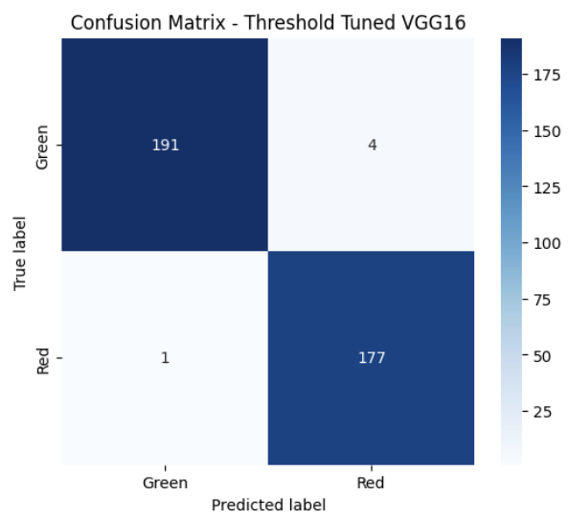
Figure 6.2: Confusion matrix after threshold tuning.
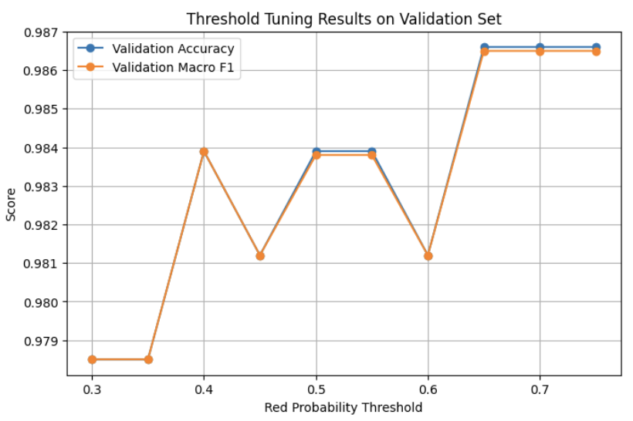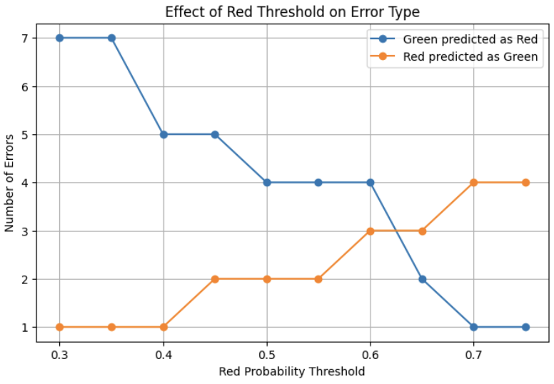
Figure 6.1: Threshold tuning validation results and error-type trade-off.
The error-type plot showed the trade-off created by threshold tuning. Increasing the Red threshold reduced Green images being predicted as Red, but it also increased the risk of Red images being predicted as Green. This matters because Red-to-Green errors are more safety-critical in autonomous driving. The selected threshold balanced these two error types well and improved the baseline, but Model 2 remained the strongest result overall.

7. Model Comparison
Model 1 achieved strong baseline performance with 97.86% accuracy, macro precision of 0.98, macro recall of 0.98, and macro F1-score of 0.98.
Model 2 produced the best overall result. It achieved 98.93% accuracy, with macro precision, recall, and F1-score all approximately 0.99, meaning the model performed strongly across both Green and Red classes and had the best balance between correct predictions and class-level reliability. It also reduced the total number of errors compared with Model 1.
Model 3, classification threshold tuning, also improved the baseline. It achieved 98.66% accuracy, with macro precision of 0.986, macro recall of 0.986, and macro F1-score of 0.986. Although this was slightly lower than Model 2, it still showed that adjusting the Red-class decision threshold improved the baseline model’s predictions.
Overall, Model 2 was selected as the best final model because it achieved the highest accuracy and the strongest precision, recall, and F1-score balance.

8. Five Unseen Test Image Predictions
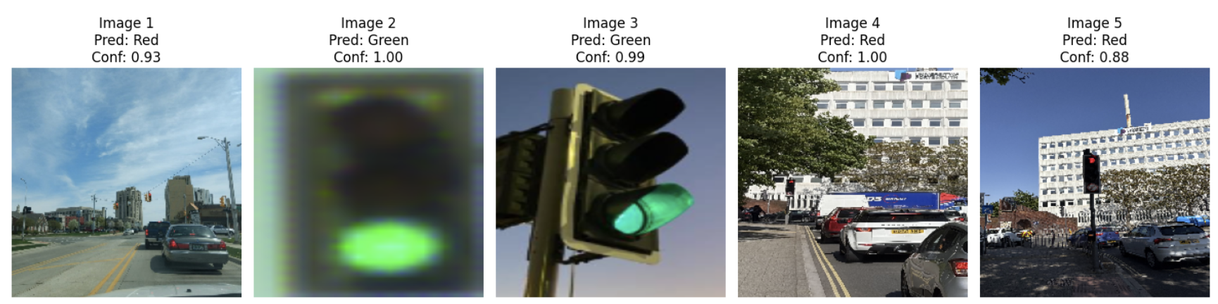
Figure 8.1: Five unseen test images results
Table 4
Five selected unseen test-image predictions using the final selected model.
Image | Actual label | Predicted label | Confidence
1 | Red | Red | 0.93
2 | Green | Green | 1.00
3 | Green | Green | 0.99
4 | Red | Red | 1.00
5 | Red | Red | 0.88

The five sample predictions demonstrate that the final model correctly classified five out of the five displayed test images. Three Red images were correctly predicted as Red, and two Green images were correctly predicted as Green.

9. Conclusion
Both improvement methods improved the VGG16 baseline. Accuracy increased from 97.86% to 98.93% with stronger regularisation and 98.66% with threshold tuning. Green recall improved from 0.96 to 0.98, while Red recall remained high at approximately 0.99. The final selected classifier was Model 2, the regularised VGG16 model. It achieved the best test accuracy and the lowest error count.

